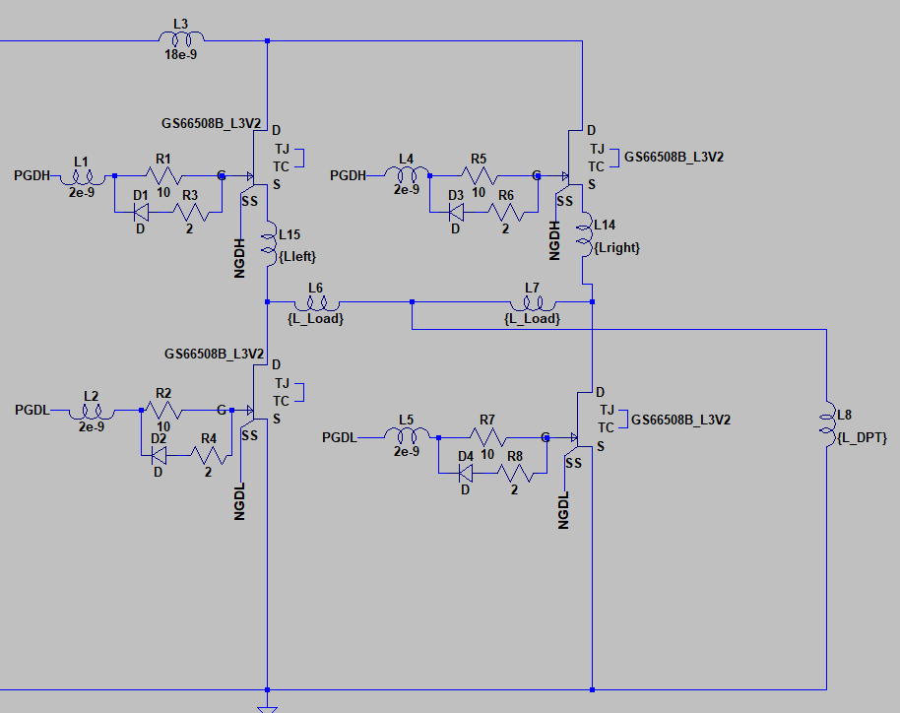

Figure 1: Simulation Circuit

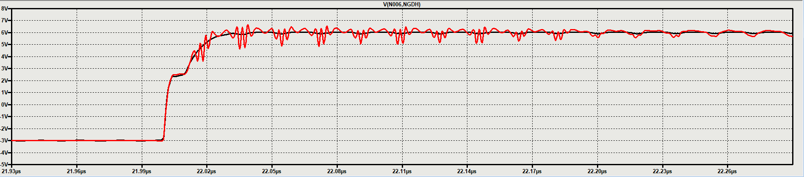

Figure 2: 1nH - 1nH & 1nH - 6nH Top Switch GS Waveforms when Load Conn. Ind. is 3nH

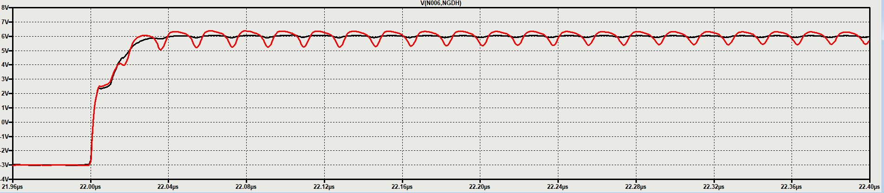

Figure 3: 1nH - 1nH & 1nH - 6nH Top Switch GS Waveforms when Load Conn. Ind. is 0 nH

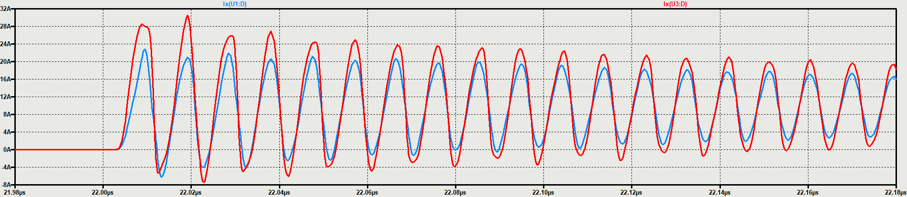

Figure 4: 1nH - 6nH Switching Current Waveforms when the Load Conn. Ind. is 3nH

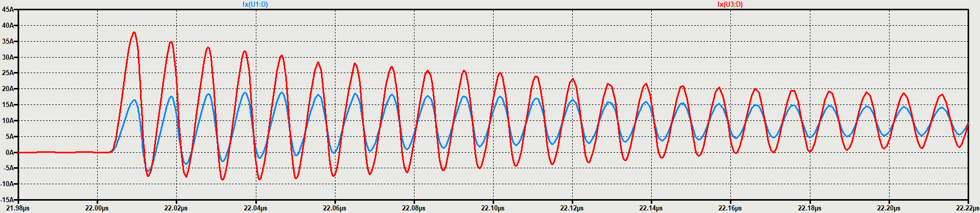

Figure 5: 1nH - 6nH Switching Current when the Load Conn. Ind. is 0